// Online Java Compiler

//1. to print an integer number given by the user.

import java.util.Scanner;

public class integer{

public static void main(String[] args) {

Scanner sc=new Scanner (System.in);2

System.out.println("enter integer");

int n=sc.nextInt();

System.out.println("num is"+ n);

}

}

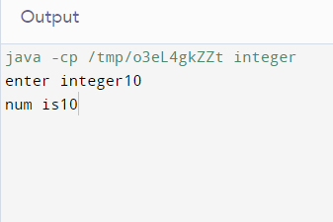

// Online Java Compiler

//2. to CHECK WHETHER THE GIVEN INPUT NUMBER IS ODD OR EVEN.

import java.util.Scanner;

public class Main{

public static void main(String[] args) {

Scanner sc=new Scanner (System.in);

System.out.println("enter number");

int n=sc.nextInt();

if (n%2==0)

System.out.println("num is"+ n+"is even");

else

System.out.println("num is"+ n +"is odd");

}

}

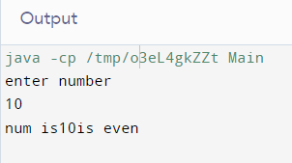

// 3. WAP to check weather a given character is vowel or consonant

import java.util.Scanner;

class A {

public static void main(String[] args)

{

Scanner sc = new Scanner(System.in);

System.out.println(" enter Char:- ");

char c = sc.next().charAt(0);

if(c == 'a'|| c == 'A'||c == 'e' || c == 'E'||c == 'i'||c == 'I'||c == 'o'|| c == 'O'|| c == 'u'|| c == 'U')

System.out.println("the is"+c+" is vowel");

else

System.out.println("tie is"+c+ " is consonant");

}

}

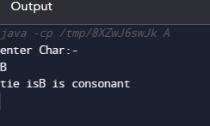

// 4. WAP to print sum all the number to any given integer number (range addition)

import java.util.Scanner;

class A {

public static void main(String[] args)

{

Scanner sc = new Scanner(System.in);

System.out.println(" enter range:- ");

int n=sc.nextInt();

float sum=0;

for(int i =1;i<=n;i++)

{

sum = sum+i;

}

System.out.println(sum);

}

}

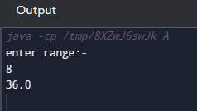

//5. WAP to print A to Z using loop

import java.util.Scanner;

class A {

public static void main(String[] args)

{

Scanner sc = new Scanner(System.in);

{

for(char i='A'; i<='Z'; i++)

{

System.out.print(i);

}

}

}

}

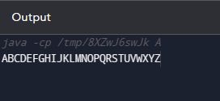

6. WAP to print greatest common divider (GCD) of 2 numbers (not running)

import java.util.Scanner;

class A {

public static void main(String[] args)

{

int gcd= 1;

int n1 = 30;

int n2 = 45;

for(int i=1;i<=n1 && i<=n2;i++)

{

if ( n1%i==0&&n2%i==0)

gcd = i;

{

System.out.println(" GCD OF " +n1+ " and " +n2+ " is " +gcd);

}

}

}

}

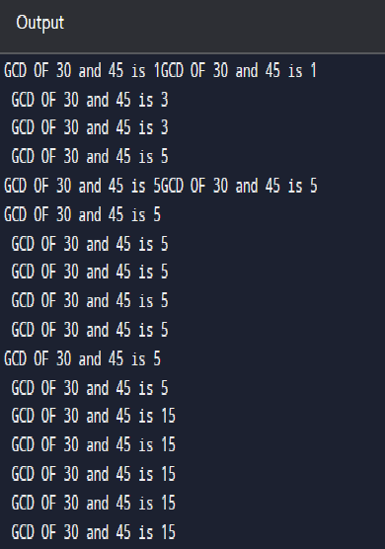

7. WAP to print a table of a given number

import java.util.Scanner;

class A

{

public static void main(String[] args)

{

Scanner sc=new Scanner(System.in);

System.out.println(" enter number :- ");

int n=sc.nextInt();

for(int i=1;i<=10;i++)

{

System.out.println(n+"\*"+i+"="+n\*i);

}

}

}

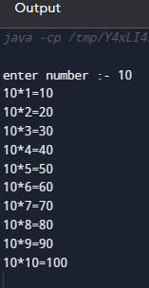

//8. factorial of given numbers

import java.util.Scanner;

public class main

{

public static void main(String[] args)

{

Scanner sc = new Scanner (System.in);

System.out.println("Enter range: ");

int n = sc.nextInt();

int fact = 1;

for (int i=1;i<=n;i++)

{

fact=fact\*i;

}

System.out.println(fact);

}

}

